

Module Leader: [REDACTED]

Digital Forensics and Incident Management

CST4230

**Technical Report**

**and Findings**

Topic: Lonewolf’s Investigation Case

**Analyst:** O. S

Company: [REDACTED]

Customer: [REDACTED]

**Date of Production:** November 2022

1. **Summary of Findings and Conclusions…………………………………..3**
2. **Background of the Investigation…………………………………………...8**
3. **Remit of the Investigation…………………………………………………....9**
4. **Exhibits Submitted for Analysis…………………………………………….10**
   1. **MDX/E1 Exhibit Details……………………………………………….10**
   2. **MDX/E1 Exhibit Imaging……………………………………………..11**
5. **Exhibit MDX/E1 Analysis Results…………………………………………..13**

**5.1 Operating System Details………………………………………...13**

**5.2 Image Analysis………………………………………………………….13**

**5.3 Presenting the Evidence……………………………………………18**

**6. Future Research Opportunities…………………………………………..20**

**7. Appendix…………………………………………………………………………….21**

**8. References………………………………………………………………………….45**

1. **SUMMARY OF FINDINGS AND CONCLUSION**
   1. Information is present on exhibit MDX/E1 to show that the computer has been active for the period 8th March 2018 00:00:00 hrs until 6th April 2018 1:55:14 hrs by the suspect, Lone Wolf was the last user of this system on 2018-04-06 13:26:27 shortly before his arrest.

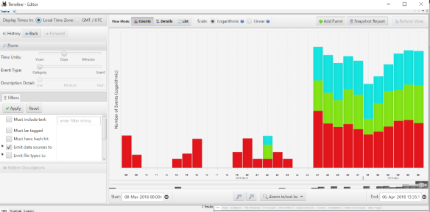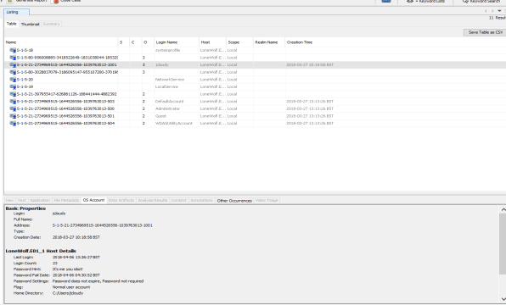

* 1. The exhibit, MDX/E1, was found to contain the following set of materials relevant to the investigation:
* Documents detailing the planning of the suspect’s desire to carry out a mass shooting, where there is an escape route, preferably near an Airport and must be gun gun-free zone. This document was named “PLANNING”, which was created on 30th of March,2018, and there was a supporting document deceitfully named “OPERATION 2ND HAND SMOKE” created on 4th of April 2018 detailing the escape route and the likely venue for the shooting incident on 7th April 2018.
* Images of the 21030 Whitefield PI, Sterling VA, 20165 venues for Town hall for our lives with expected speakers: Representative Comstock, all congressional candidates, Senator Kaine and Warner and local government representatives from Democratic party, Cascades library meeting room B Sterling VA, a Google map direction and description from the above address to Dulles International Airport and nine other google maps.
* An American Airlines (AA), Etihad Airlines, Delta Airline, Korean Air and Qatar Airline flight search from IAD to DPS in Indonesia, scheduled for the 7th of April and to the 21st of April 2018(on AA only) and a hotel reservation search of the Sea Breeze Candidasa, Mendira Beach and Tegallalang Hotel, both in Indonesia.
* The Cloudy manifesto is another document that details some reasons behind his planned action. He strongly believed in a society where individuals should protect themselves because of the governments and elected officials’ failure. He said, “If you choose not to protect yourself, that is YOUR choice.” Your choice to be a sheep should not affect others’ abilities to protect themselves.
* A document shows that kills Americans has heart disease/Strokes as the highest of 800,000 while firearms homicides are 11,078, he was critical, while unhealthy foods are not outlawed, even though they have the highest number of victims. He further made known, while he called himself LONEWOLF, “Something must be done to show that gun-free zones do not work and will never work. So, I intend to break the law. Because that is what the criminals will do. No matter your laws, when they decide to act, they will.
* So, I will be the lone wolf who helps demonstrate to the American Public that laws and signs will not work. Only the ability to protect yourself will work.” “You will soon see when the blood has been shed and the defenceless bodies stacked high. I will do what I must. No matter who is hurt, the collateral damage will be worth it. I will be the Lone Wolf.”
* He is a supporter of mass shooters, the National Rifle Association (NRA), and the Second Amendment. He has images and quotes that support citizens being armed. He had several gun images of pistols and rifles. He visited gunbroker.com sixty-five times in search of gun information. Prominent among these guns are the Ruger 10-22, Keltec sub-2000 9mm, FN P90 on YouTube, concealable tactical rifles, gun black market seller addresses Norther VA Gun Works 7518 Fullerton Rd # K, Springfield, VA 22046 and multiple YouTube video searches and web searches for guns and gun sellers.
* Weather updates are particularly important to him because of his plan, which can be affected by unfavourable weather conditions, as said in one of his cloud notes. He visited online weather trends 360 and others. He also visited weather.com 53 times, including a day before he was arrested.
* HTML Web searches and web history with relevant keywords reveal that the suspect was at the tail end of planning a mass shooting and fleeing the country thereafter.
* Answers to the remit of this investigation:

1. Does the suspect have any intention and confession to commit the offence? The Cloudy thoughts and manifesto documents available revealed his intention, but his confession could not be ascertained because the available audio files cannot confirm this.
2. Does the suspect have any documented plan to commit the offence? None of the available documents could prove this beyond a reasonable doubt.
3. Does the suspect have a plan to be at 21030 Whitfield Pl, Sterling, VA, on the 7th of April? Only a Google map supported this, which may not be true.
4. Does he have a plan to travel out of the country on the same day? Only travel dates search available, and no confirmed ticket.
5. Who else is aware of this plan? We have a name called Paul, but no other details to confirm the exact information.
   1. Looking at the Actus Reus and Mens Rea (guilty act and guilty mind), all documents and evidence mentioned above could be classified as mens rea and just mere intentions, which are not enough to convict a suspect, and there may be a need for further investigations.
6. **BACKGROUND TO THE INVESTIGATION**
   1. The suspect (Lone Wolf) was arrested by the Police after his brother reported him for his suspicious and unusual activities.
   2. Based on the laws, guidelines, and protocols for conducting the digital investigation, they were strictly adhered to in this report. According to the Computer Misuse Act (1990), updated with the police and Justice Act (2006), to access or modify stored data from another person’s machine without permission is considered a criminal act. Consequently, a search warrant was obtained for Lone Wolf’s computer. In order to validate his brother’s suspicion.
   3. Furthermore, the standard of International Organisation for Standardisation (ISO), in collaboration with the International Electrotechnical Commission (IEC) of 27041-27043, which offers guidance on the assurance aspects of digital forensics, what happens after digital evidence has been collected, and the broader incident investigation activities, within which forensics usually occur, were all maintained. Association of Chief Police Officers (ACPO) guideline for computer-based evidence, which holds that any evidence produced to the court must be proven to remain in the original state of acquisition, without alteration; accessed by a competent person capable of explaining their actions and implication; able to be preserved in a way that another examiner would arrive at the same conclusion (An Explanation of ACPO Guidelines for Digital Based Evidence, 2022). As a result, a third party was employed in Lone Wolf’s case to maintain an audit trail, avoid alteration, while preserving the evidence’s chain of custody.
   4. Consequently, his laptop was examined by [REDACTED] on Friday, April 6, 12:50:44 2018 using the ADI3.1.1.8 software. I have been provided with the drive image obtained and will investigate the contents using the Autopsy 4.19.3 software. The drive image obtained and presented to me is now referred to as MDX/E1 with seal number E6430.
7. **REMIT OF THE INVESTIGATION**
   1. The [REDACTED] has requested that exhibit MDX/E1 be analyzed for any evidence of mass shooting intention.
   2. If any evidence is found, then the following can also be answered:
      1. Does the suspect have any intention and confession to commit the offence?
      2. Does the suspect have any documented plan to commit the offence?
      3. Does the suspect have a plan to be at 21030 Whitfield Pl, Sterling, on the 7th of April?
      4. Does he have a plan to travel out of the country on the same day?
      5. Who else is aware of this plan?
8. **Exhibits Submitted for Analysis**
   1. [REDACTED], of [REDACTED], took receipt of exhibit MDX/E1 from MP 321, of [REDACTED], whilst on duty at [REDACTED] premises. Details of the exhibit are recorded on a GSL01 Exhibit Receipt Form and are retained within the case folder. These are summarised in Table 1.

**Table 1 Exhibit(s) Received**

|  |  |  |
| --- | --- | --- |
| Exhibit Number | Seal Number | Description |
| MDX/E1 | E6430 | Drive Image |

4.2. **MDX/E1 Exhibit Details**

* + 1. The exhibit was examined and indexed using the Autopsy 4.19.3 software, which I installed on 5th November 2022 and details recorded on GSL02 Exhibit Continuity Forms were retained within the case folder. This information is summarised in Table 2.

**Table 2 Exhibit MDX/E1 Details**

|  |  |
| --- | --- |
| Item | Description |
| Type | Laptop Computer |
| Make | Dell Inc |
| Model | Latitude E6430 |
| Name | DESKTOP-PM6C56D |
| Processor | AMD64 |
| Device ID | |  |  | | --- | --- | |  | c9efaa8b-5b26-465f-a6f9-272fdbf8bcf8 | |
| System Date & Time | Fri Apr 6 12:50:44 2018 |
| Accurate Date & Time | Fri Apr 6 12:50:44 2018 |

* 1. **Exhibit MDX/E1 Imaging**
     1. A Forensic image was made of the exhibit using FTK Imager version 3.1.1.8, and a Tableau write-protected IDE Forensic Bridge – write protection is used to prevent any modification to the data contained on the exhibit. Upon completion of a Forensic Image a unique digital signature is produced, this can be recreated at any point to verify that the Forensic image has not been altered - this is referred to as an MD5 hash. Details of the MD5 hash are provided in Table 3.

**Table 3 Exhibit MDX/E1 MD5 Hash details**

|  |  |  |
| --- | --- | --- |
| Hash Type | MD5 Hash | Note |
| Acquisition | 7af48fa65519e84246b1729e5b68f140 | Match |
| Verification | 7af48fa65519e84246b1729e5b68f140 |

1. **Exhibit MDX/E1 Analysis Results**

5.1. **Operating System Details**

* + 1. The currently installed Operating System details were recovered from the exhibit. These details are recorded in Table 4. This information shows that the computer has been active for the period 2nd January 1970 until 6th April 2018 by the suspect, Lone Wolf.

**Table 4 Operating System Details**

|  |  |
| --- | --- |
| Item | Description |
| Operating System | Microsoft Windows 10 Education |
| Installed | 2018-03-27 13:13:27 BST |
| Product Information | 00328-00089-23637-AA141 |
| Last Shutdown | 2018/04/06 13:40:37 |
| Registered Owner | Lone Wolf |
| Registered Organization | N/A |

* 1. **Image Analysis**
     1. There are numerous digital image formats present on the computer. The formats GIF, BMP, DOC, HTML, PDF, JPEG, RTF, TXT, AUDIO and VIDEO can be recovered and reviewed. Therefore, analysis is concentrated on these file types.
     2. All the above-mentioned files were recovered from the exhibit; this was a total of one hundred and Sixty-Five thousand Four hundred and thirty-five (165,435) files for review. It was possible to reduce the number of files for review to sixty-one Thousand One hundred and forty-two (61,142).
     3. Following a review of the files, a total of Five Hundred and Thirty Three files (533) from my tags what discovered what are believed to be likely plans to commit mass shooting at 21030 Whitfield inside Cascades library meeting room B Sterling, VA. Of these Eighty-Eight (88) were unique.
     4. The images were automatically graded in line with the United States Sentencing Commission Guidelines Manual 2021 for terrorism offences, see Table 5. This identified that all the files observed were gradable at level 4 as stipulated by the manual for such offence and planned action(s) of the suspect.

**Table 5: The United States Sentencing Commission Guidelines** [**§**](https://casetext.com/statute/united-states-code/title-18-crimes-and-criminal-procedure/part-i-crimes/chapter-113b-terrorism/section-2331-definitions) **3A1.4**

|  |  |
| --- | --- |
| **Level** | **Description** |
| 1 | Personal notes and confession detailing the intention to conduct a mass shooting |
| 2 | Actions taken for the planned incident with Images of potential guns, training on armed weapon usage and potential sellers. |
| 3 | Planned disruption and ready to break the law as a lone wolf, planned to shed innocent blood, want defenceless bodies stacked high and escape via IAD to Indonesia the same day. |
| 4 | The Suspect planned to stop the ongoing anti-second amendment protest of Democratic lawmakers’ proposal for its amendment with intimidation, force the lawmakers to jettison any such ideas and cause collateral damage to the whole country. |

* + 1. The location of relevant files was reviewed, which identified that most of the important evidence notes were located within the folder named “/img_LoneWolf.E01/vol_vol7/Users/jcloudy/OneDrive\” embedded in **FILEVIEWS → FILETYPES → BY EXTENSION → DOCUMENTS → OFFICE (51).** This folder suggests the suspect, Lone Wolf, was planning a possible mass shooting, and he is monitoring weather conditions and faithfully waiting for the Saturday, 7th of April event and open fire on his targets.

## 

## 5.2.5. Timeline of the events:

**30.03.2018**

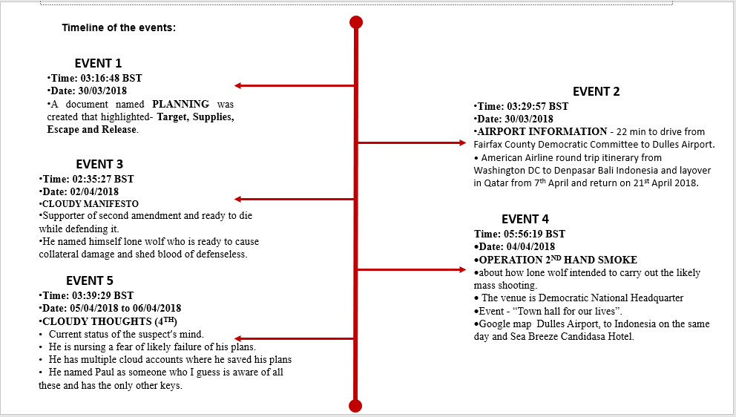

## 5.2.6. EXHIBIT NUMBER AND DESCRIPTIONS

|  |  |  |
| --- | --- | --- |
| S/N | DESCRIPTIONS | NUMBER |
| 1 | Lone wolf’s FTK image files | MDX/E1 |
| 2 | Planning | MDX/E2 |
| 3 | Airport Information | MDX/E3 |
| 4 | Cloudy Manifesto | MDX/E4 |
| 5 | Operation 2nd Hand | MDX/E5 |
| 6 | Cloudy Thoughts (4th) | MDX/E6 |
| 7 | CD-R | MDX/E7 |
| 8 | Contemporaneous Notes | MDX/E8 |
| 9 | Autopsy Report | MDX/E9 |
| 10 | Other Investigation Evidence- Excel, JPEG, HTML etc. | MDX/10 |

## 5.3. Presenting the Evidence:

## 5.3.1. Event number one and two:

## The Document named Planning and Airport Information kick start this idea of mass shooting. The planning document was divided into four parts which are Target. It represents the Venue, which is expected to have good escape route, near to Airport and must be Gun Free zone. Supplies, it stated two-gun black markets, and types of possible gun, latex gloves, Velcro tear away clothing and cash. Escape, it includes, no extradition countries, flight itinerary which I think is where the Airport Information document which shows an American Airline reservation from Dulles Airport to Indonesia and layover at Hamad Airport in Qatar. The last is Release which tells us the reason behind having one drive, google drive, drop box, amazon S3 and box.com cloud accounts, respectively. (Attachments for MDX/E2 AND MDX/E3).

## Event number three:

## Prominent images, websites, notes, and write ups were read, visited, and downloaded between 31/3/18 and 02/04/2018.This document started with three different question statement; What happens when the government can no longer protect you? What happens when you need protection from the government? What happens when you can no longer protect yourself? He went one to show while he dislikes the agitations and protest for the repeal of second amendment. He is frustrated with the hypocrisy of government looking at the statistics of what kills American of which heart diseases/stroke is the highest while firearm and homicides is the least and the major cause of concern to the government. He shows in many ways his supports for self-protection, National rifle Association, Gun related articles, he declared himself as the lone wolf, who is ready to shed the blood of the defenseless, cause revolution and hope the collateral damage will worth it. (Attachments for Exhibit MDX/E4).

## Event number four:

## Images, websites, notes, and write ups were read, visited, and downloaded between 02/04/18 and 04/04/2018. And Operation 2nd hand smoke document details the operations, venue, date, and escape route plans of lone wolf. The suspect is likely to attend the democratic organized town hall project event tagged “Town hall for our lives.” At Cascades library meeting room B Sterling VA (21030 Whitfield place) is like to be the venue, he has a google map to guides his movement from the venue to Dulles Airport enroute to Indonesia probably through Koren Air. He visited several websites to make enquiry on his probably escape destination. There key words are, is there a map of gun free zones, where the dollar goes farthest Vietnam or Indonesia, Tegallalang hotel, how to improve your gun argument, anti-gun rally near me, Velcro tear away clothes, etc. (Attachments for Exhibit MDX/E5).

## Event number five:

## Images, websites, notes, and write ups were read, visited, and downloaded on 04/05/2018. And Cloudy Thoughts (4th) document was created to give us the current state of mind of the suspect, his fears, emotions, and determination to continue the planned shooting plan. He is ready to give up his life for this course. He is saving everything to the cloud on several accounts and the only record will remain in the cloud and Paul will have the only other keys. He hopes the weather is clear for him to perform the act. Some of the key words searched on the above-mentioned date are moving desktop files to one drive, google drive, drop box and box.com cloud accounts. Larry king interview on “time to repeal poorly written second amendment.” Ten best things to do in Bali, 19 Indonesia Expat jobs, is it legal to carry large sums of cash out of the country? Us citizen getting an overseas account, how to smuggle cash through the Airport and can I strap cash to myself and walk through TSA? Etc. (Attachments for Exhibit MDX/E6).

* + 1. These images are now produced on CD-R as exhibit MDX/E7. This disc is encrypted using one of the strongest encryption methods currently available, ROT13.

1. **Future Research Opportunities**
2. Two SanDisk flash drives used on 27/03/2018
3. Who is Paul?
4. Did he pay for the ticket and hotel?
5. Who is behind the brother’s chat (292) from the web history, and what is the content?
6. [REDACTED], [REDACTED], Twitter Account, Dropbox Account, OneDrive Account, Amazon Cloud Account and Google Drive Account, respectively.
7. His telephone calls logbook and Crypto wallet information.
8. Was he fired for a Sexy Instagram photo?

**7.0 Appendices**

**7.1. Attachments for Exhibit MDX/E2 and E3: PLANNING AND AIRPORT INFORMATION**

**Time: 03:16:48 BST AND 03:29:57 BST**

**Date: 30/03/2018**

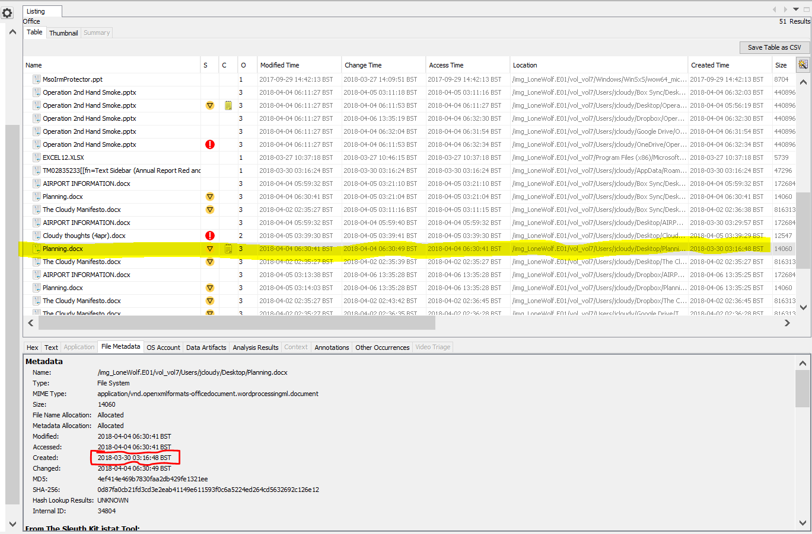

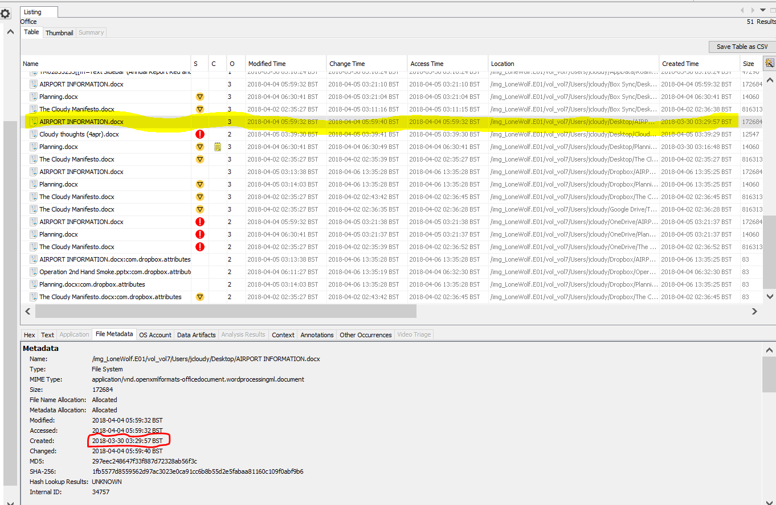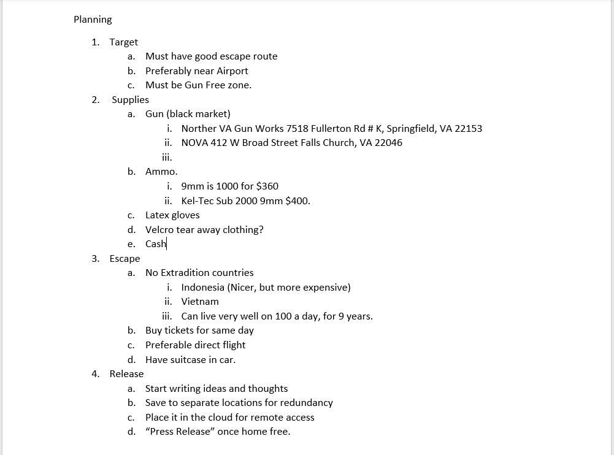

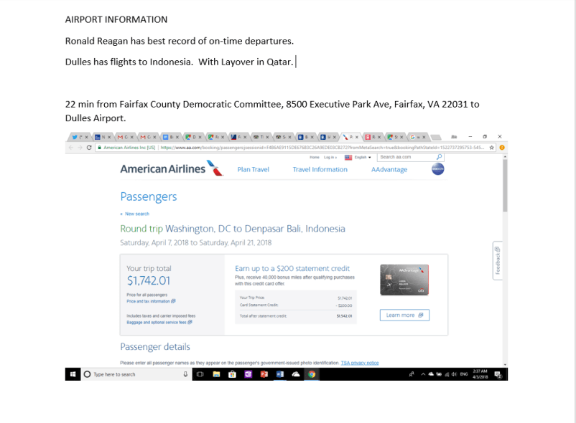

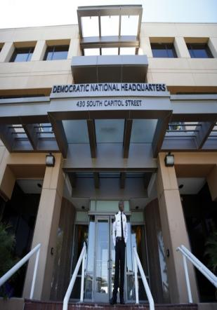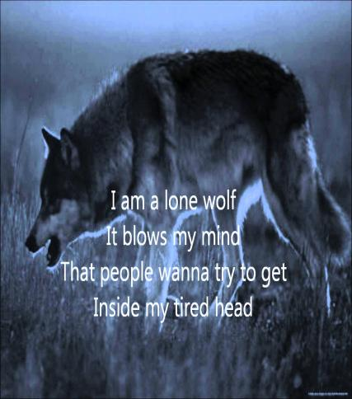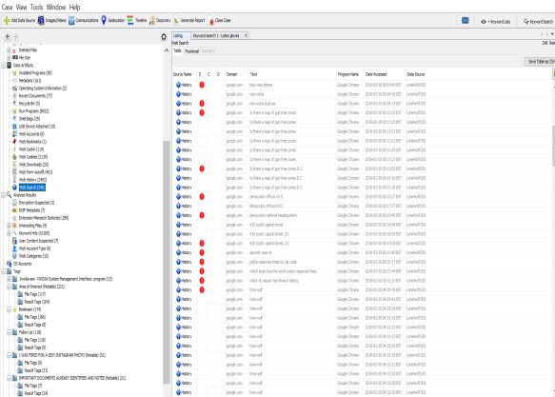 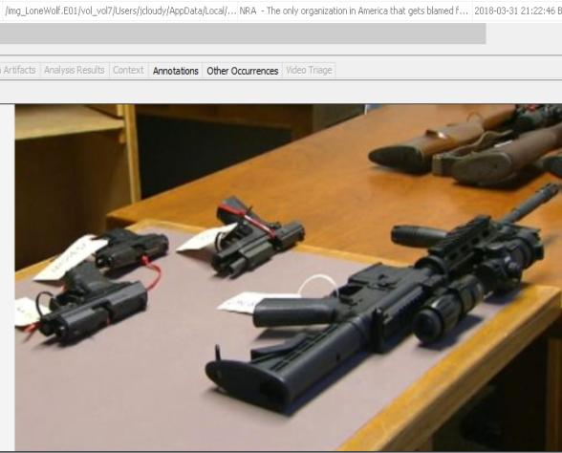

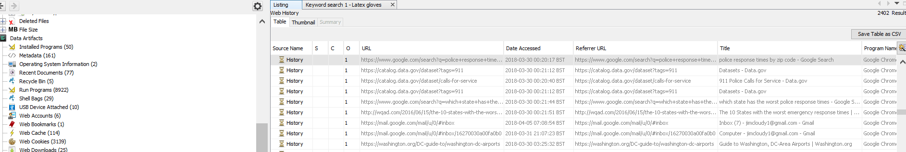

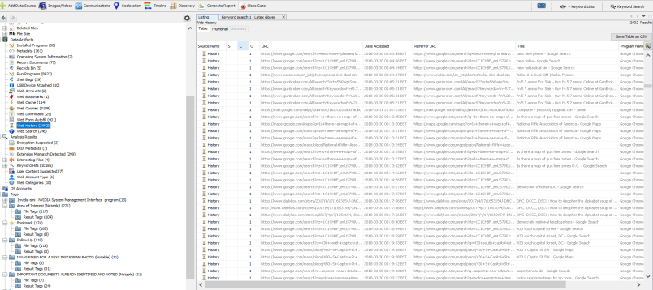

* 1. **Attachments for Exhibit MDX/E4: THE CLOUDY MANIFESTO**

**Time: 02:35:27 BST**

**Date: 02/04/2018**

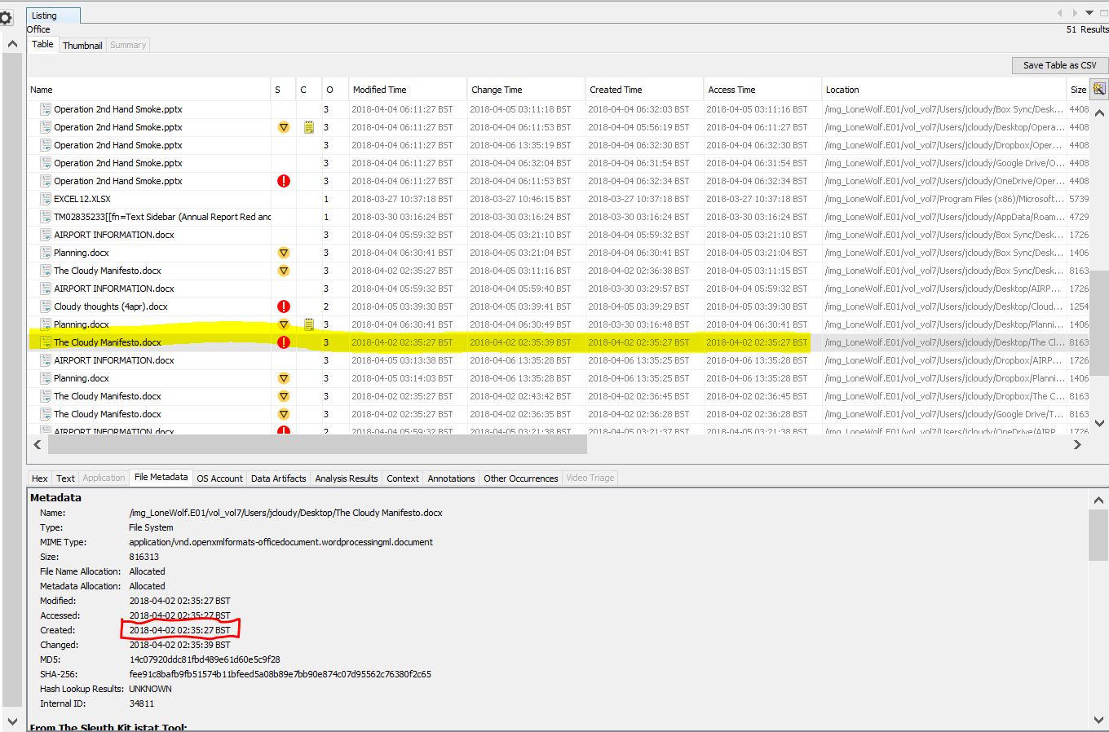

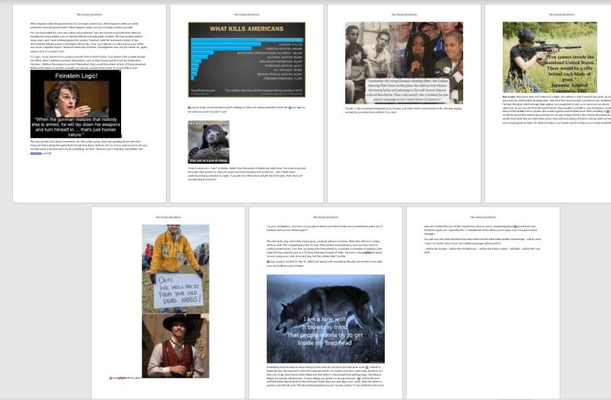

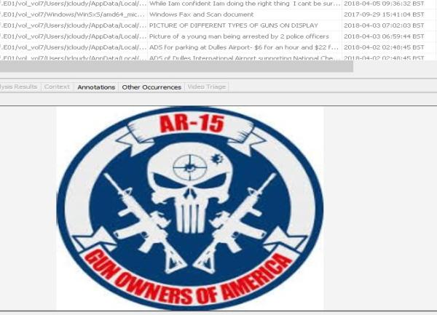

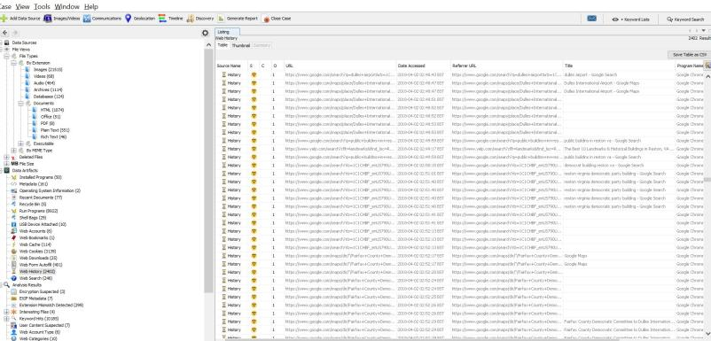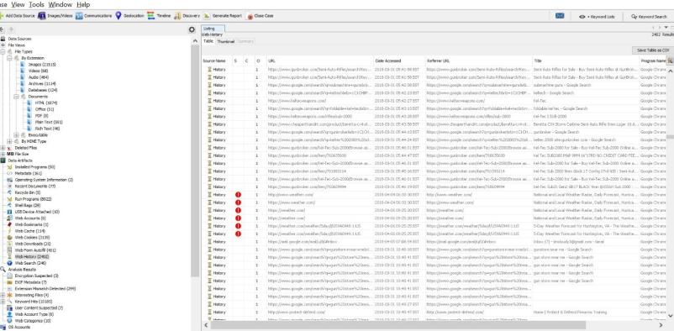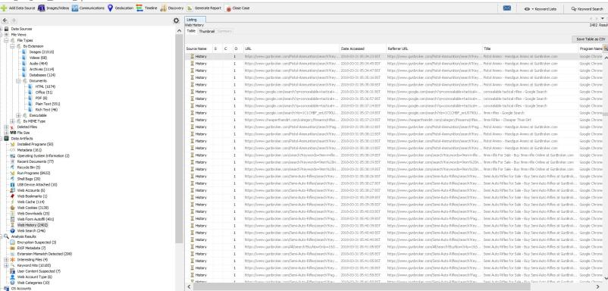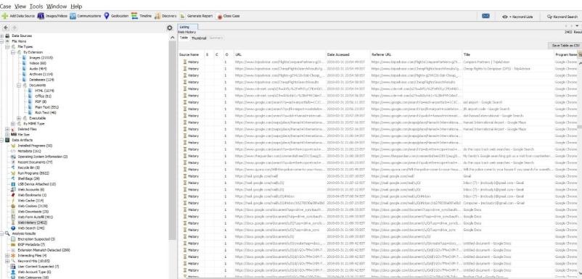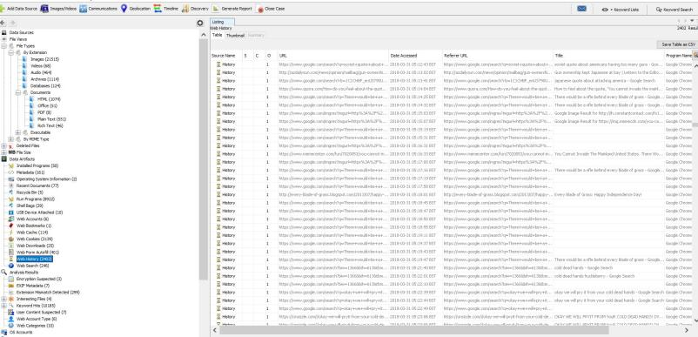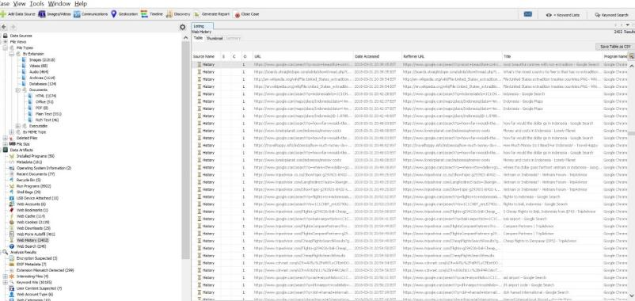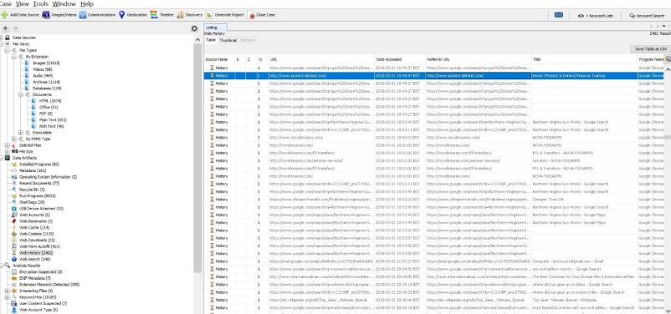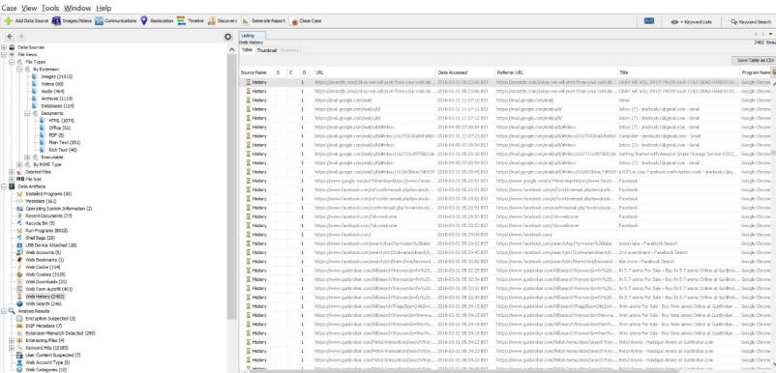

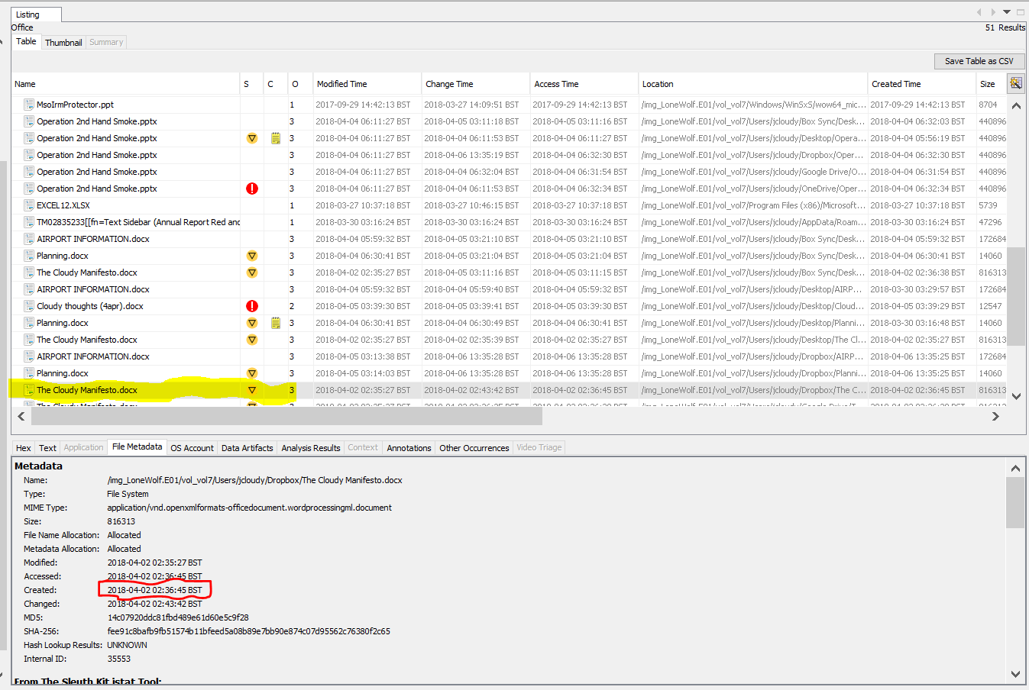

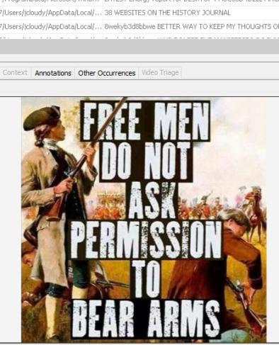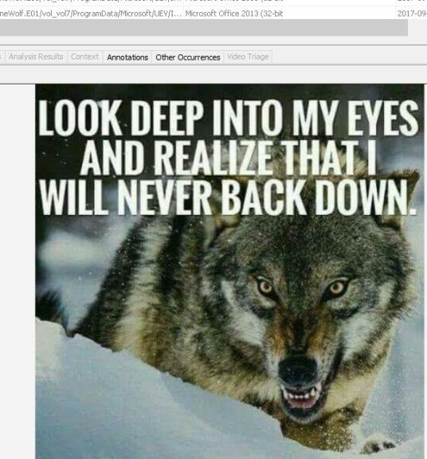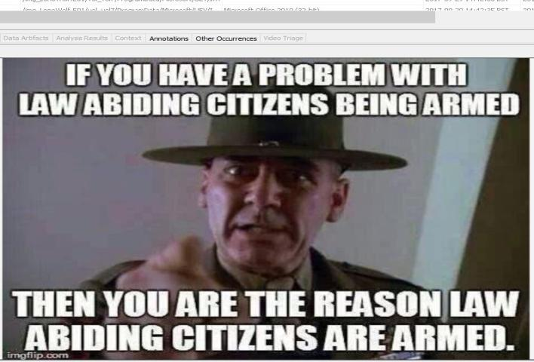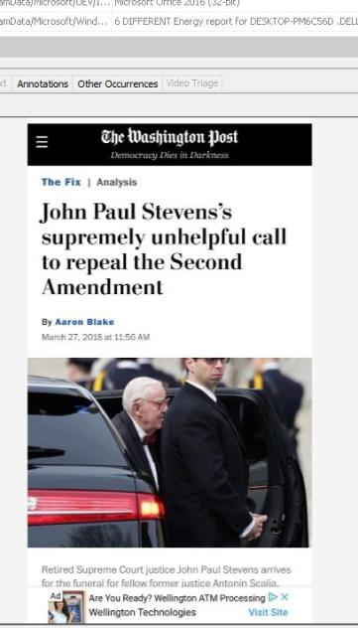

**7.3. Attachments for Exhibit MDX/E5: OPERATION 2ND HAND SMOKE**

**Time: 05:56:19 BST**

**Date: 04/04/2018**

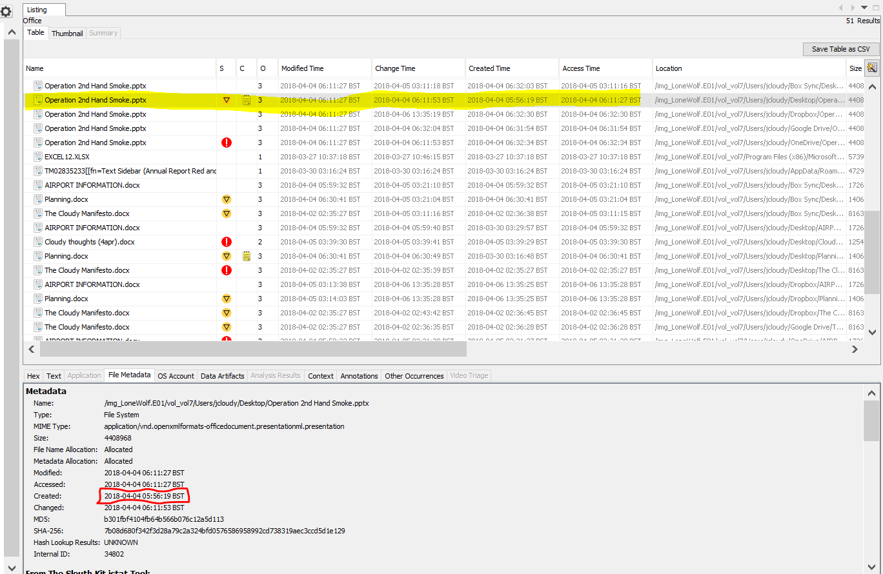

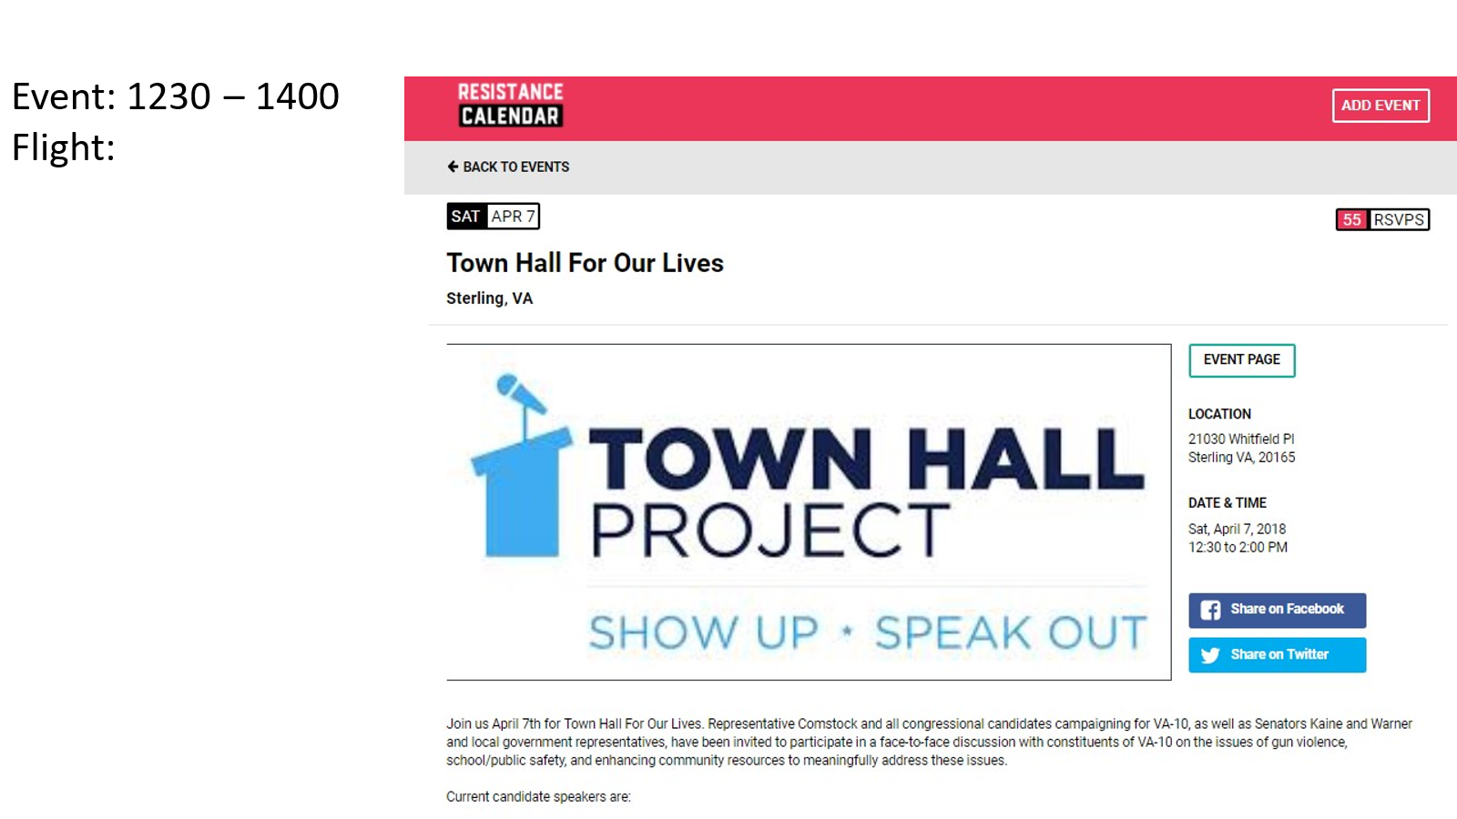

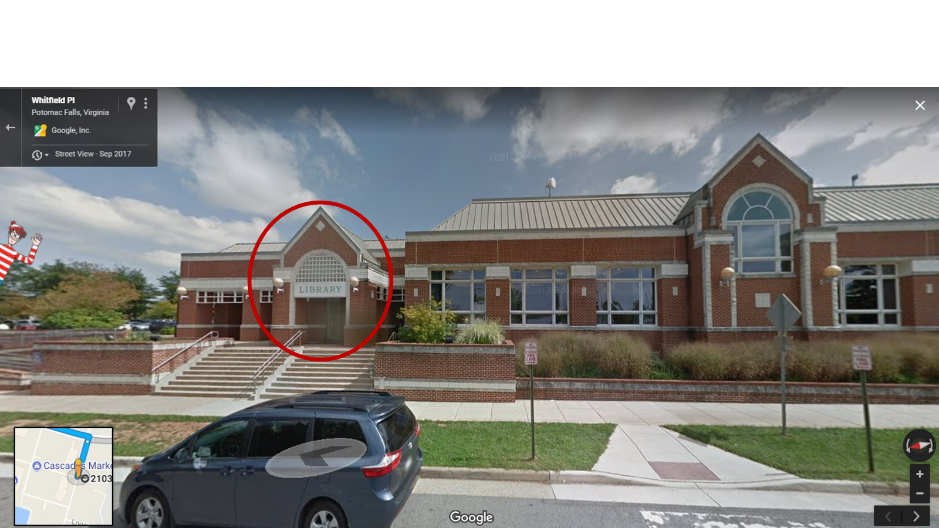

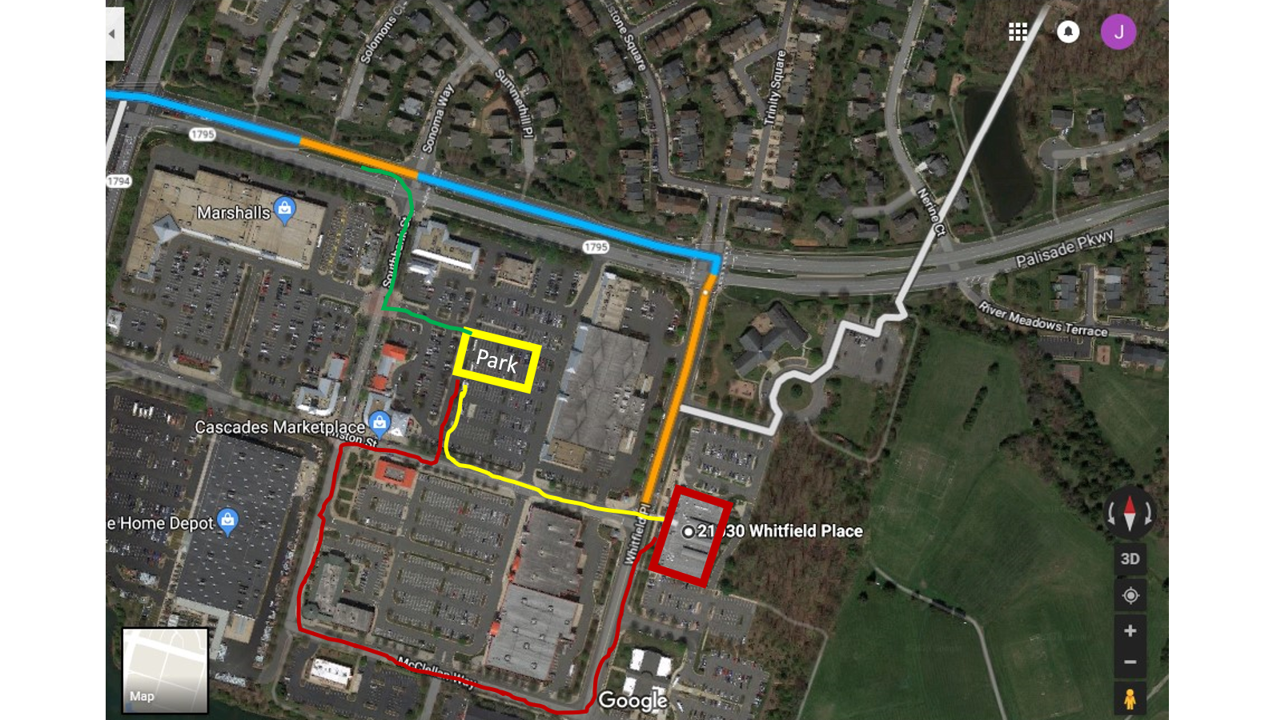

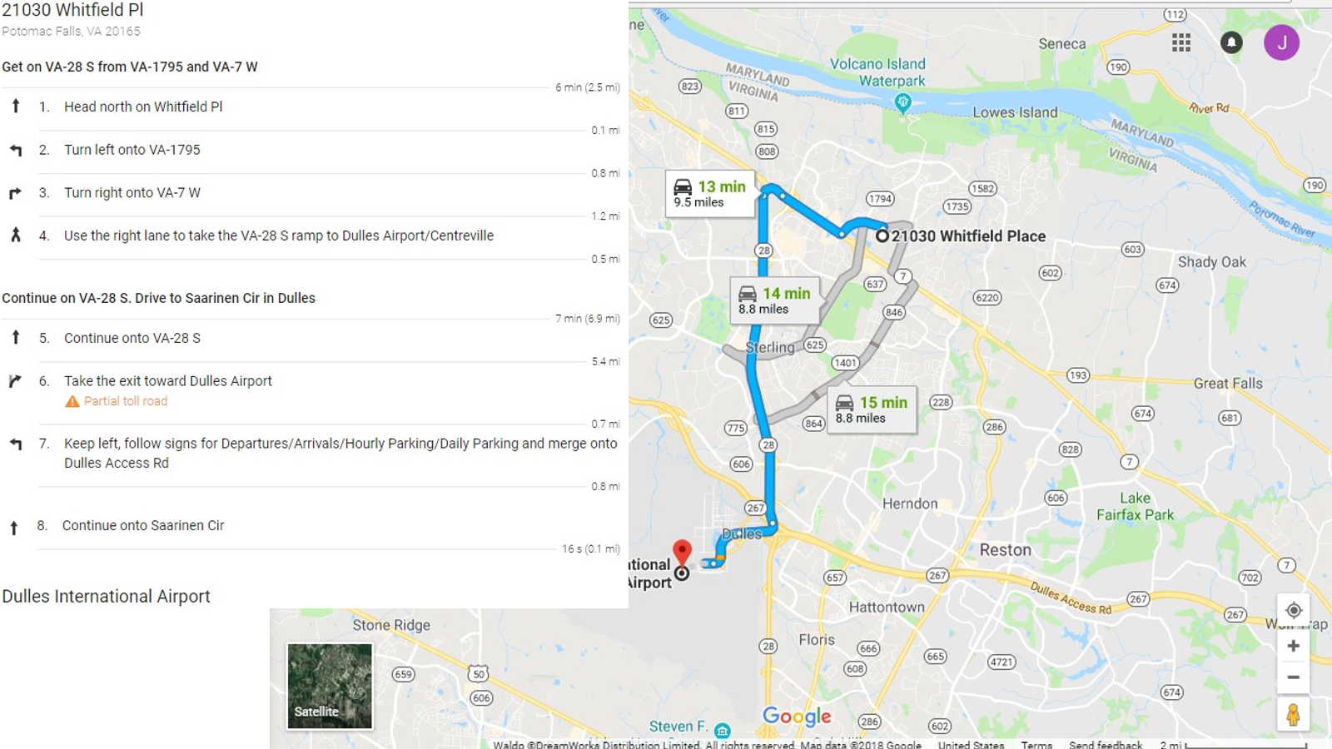

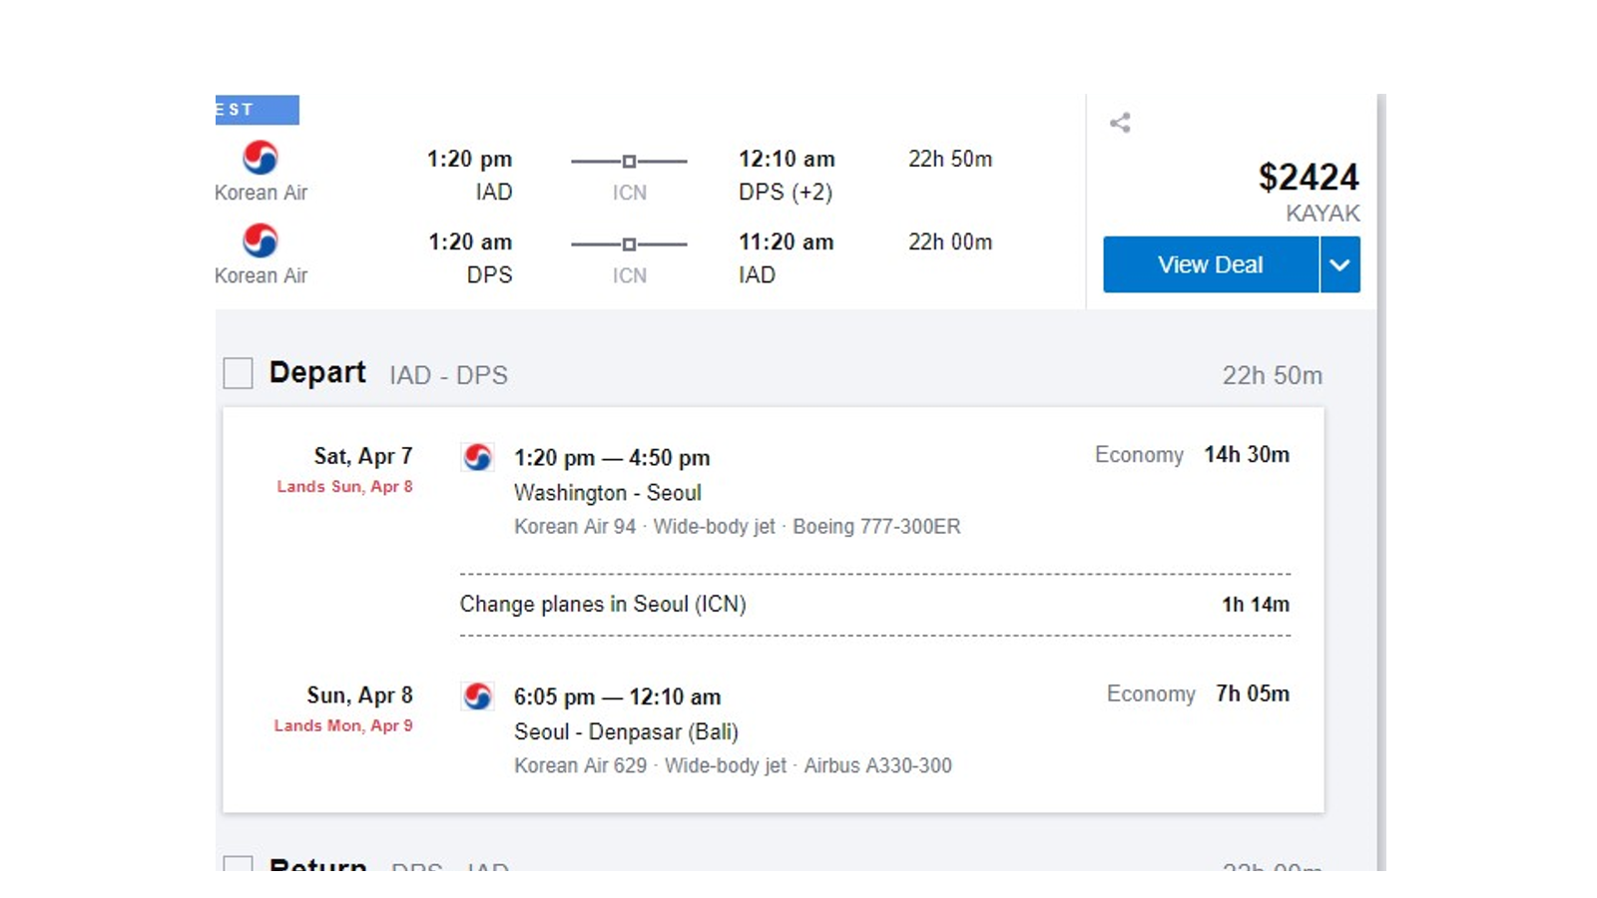

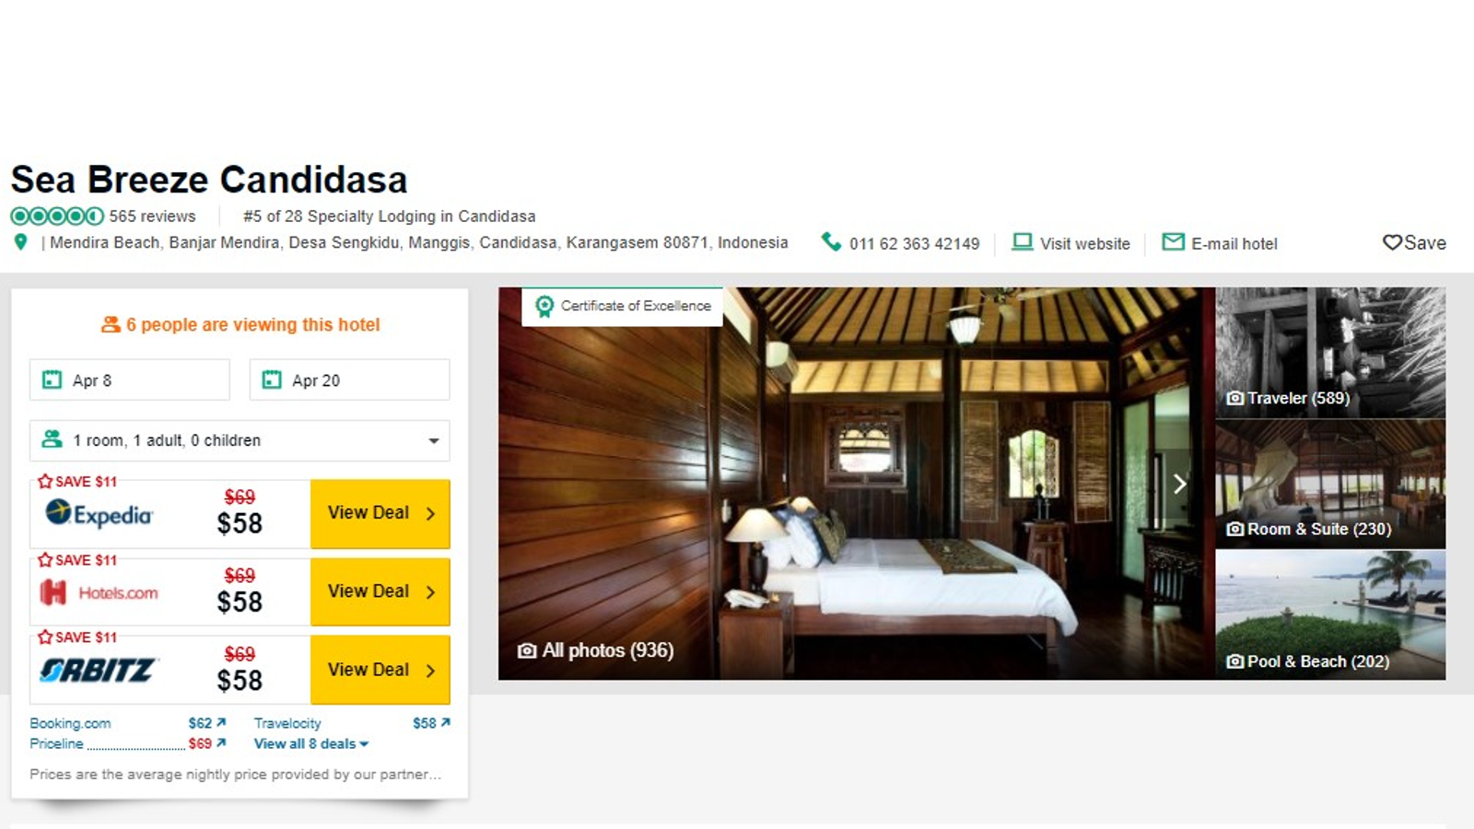

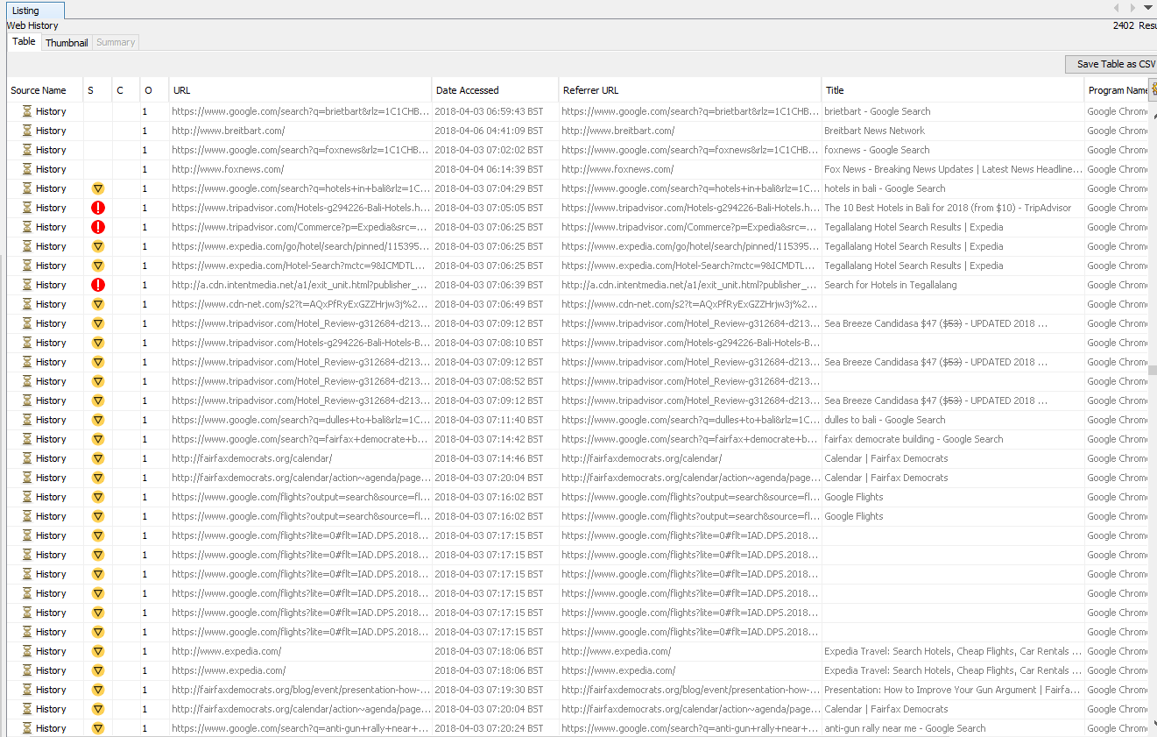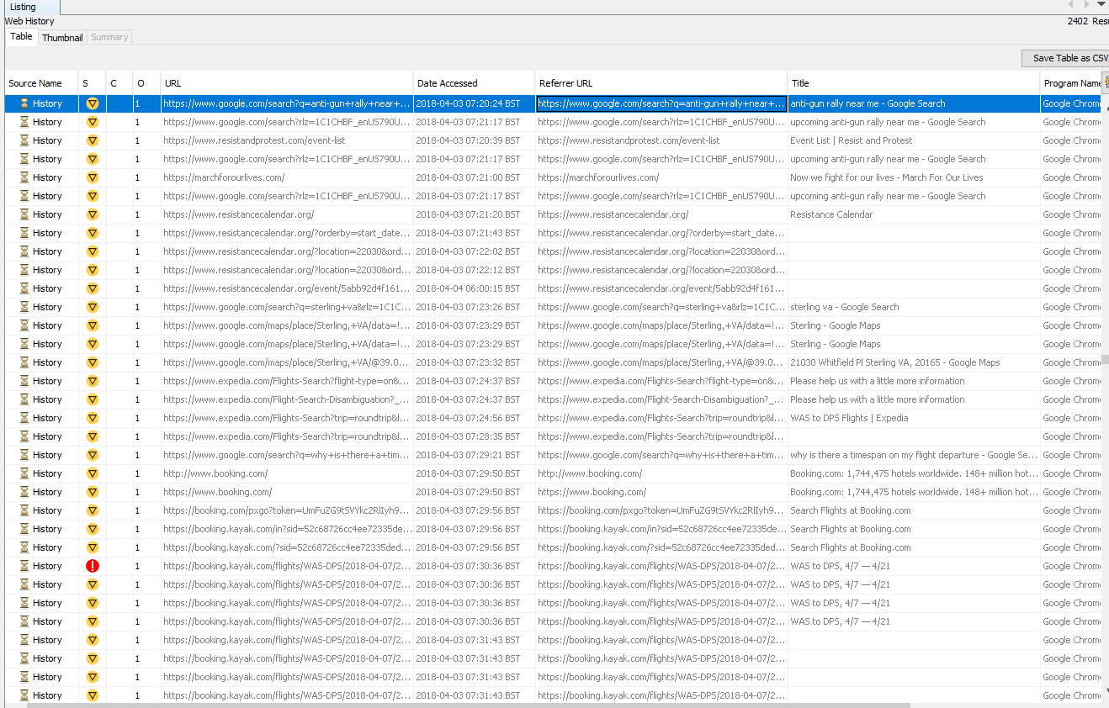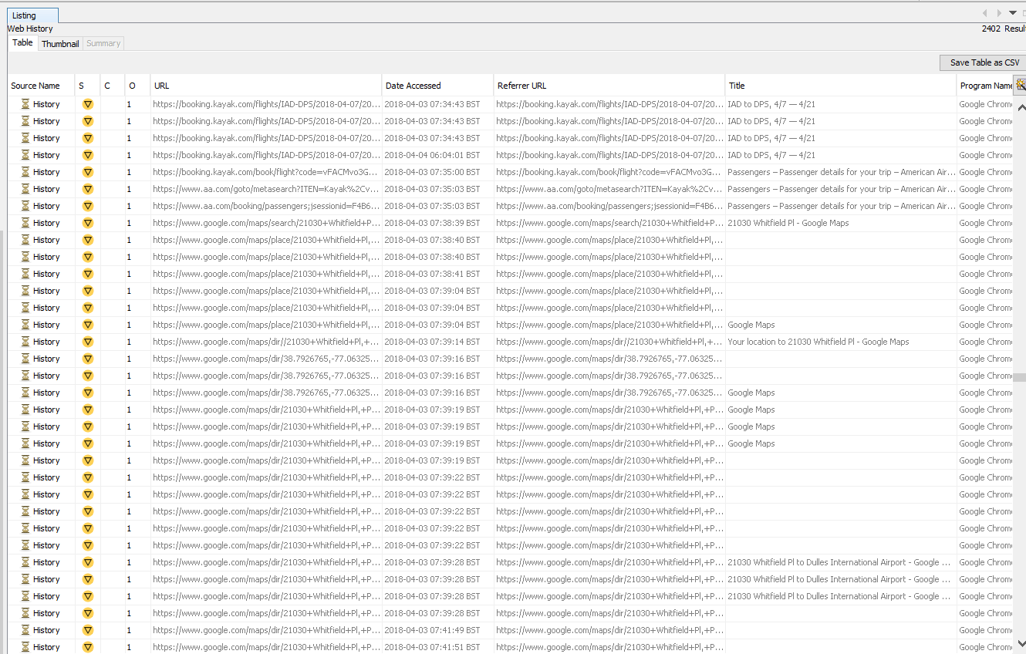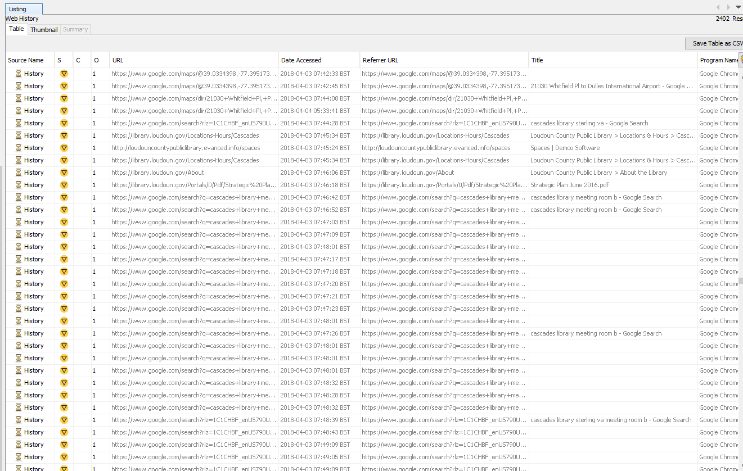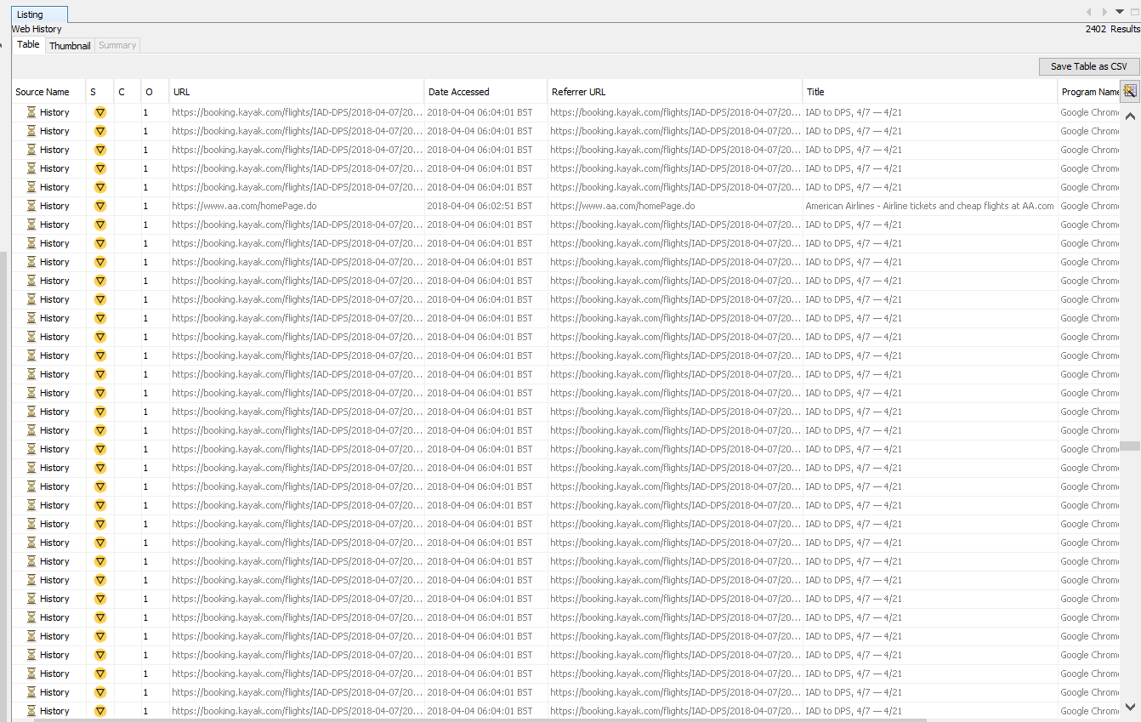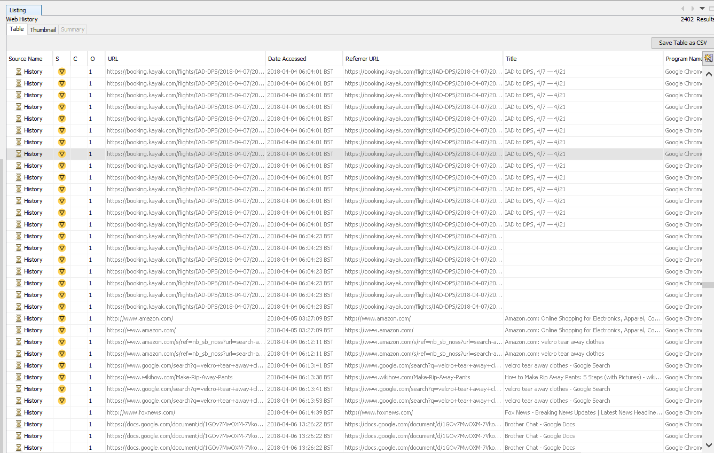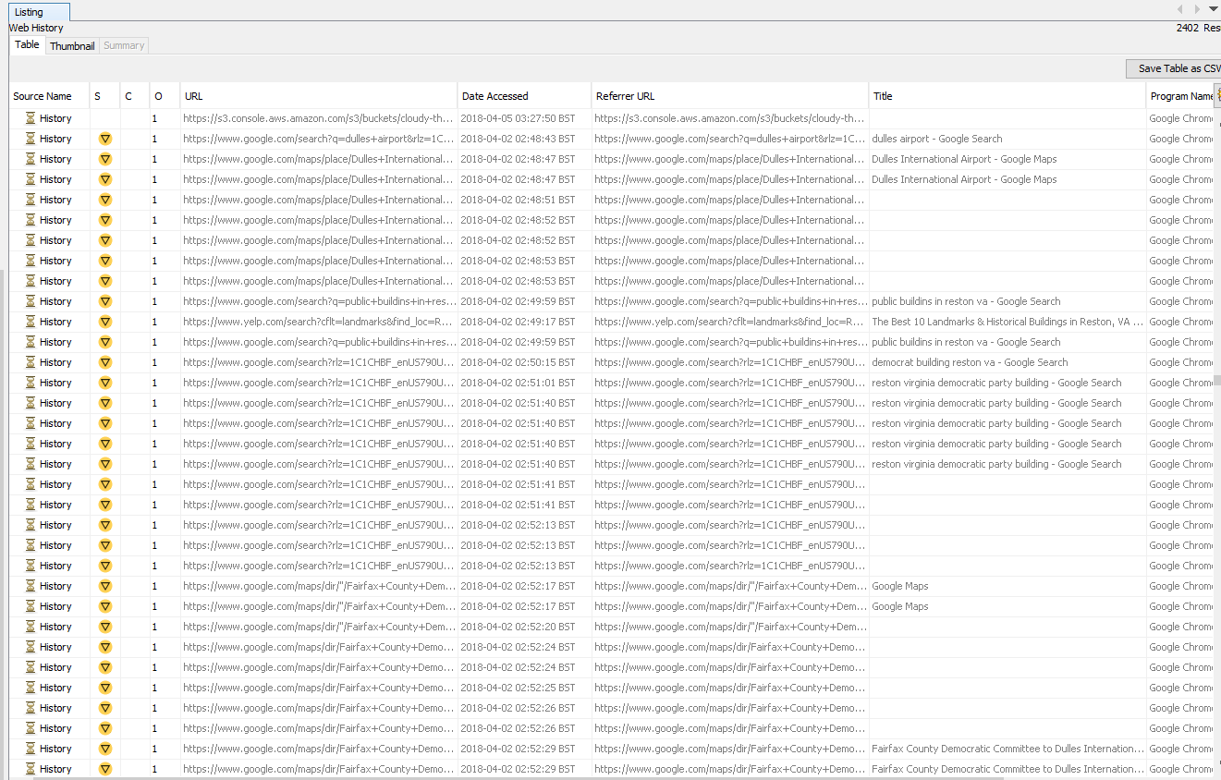

**7.4. Attachments for: CLOUDY THOUGHTS (4TH)**

**Time: 03:39:29 BST**

**Date: 05/04/2018**

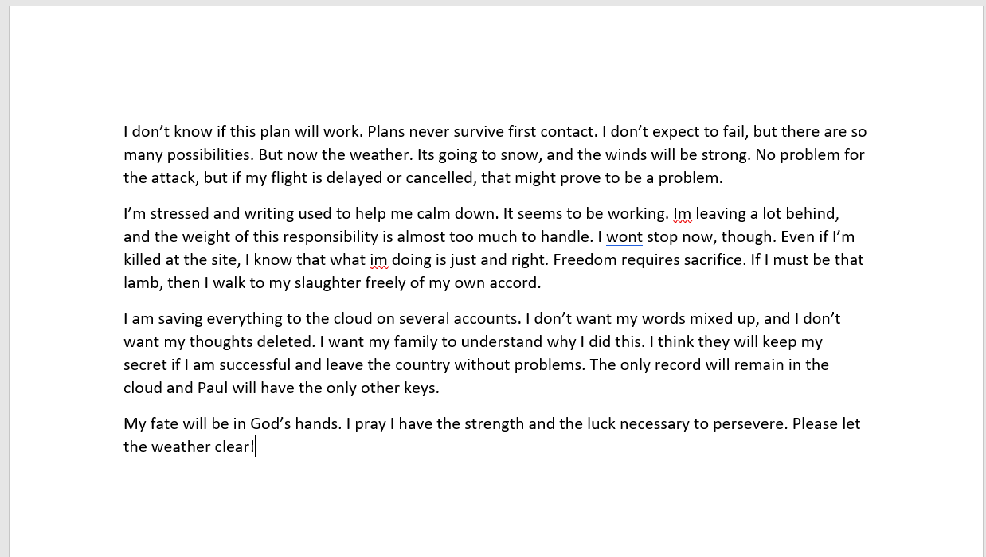

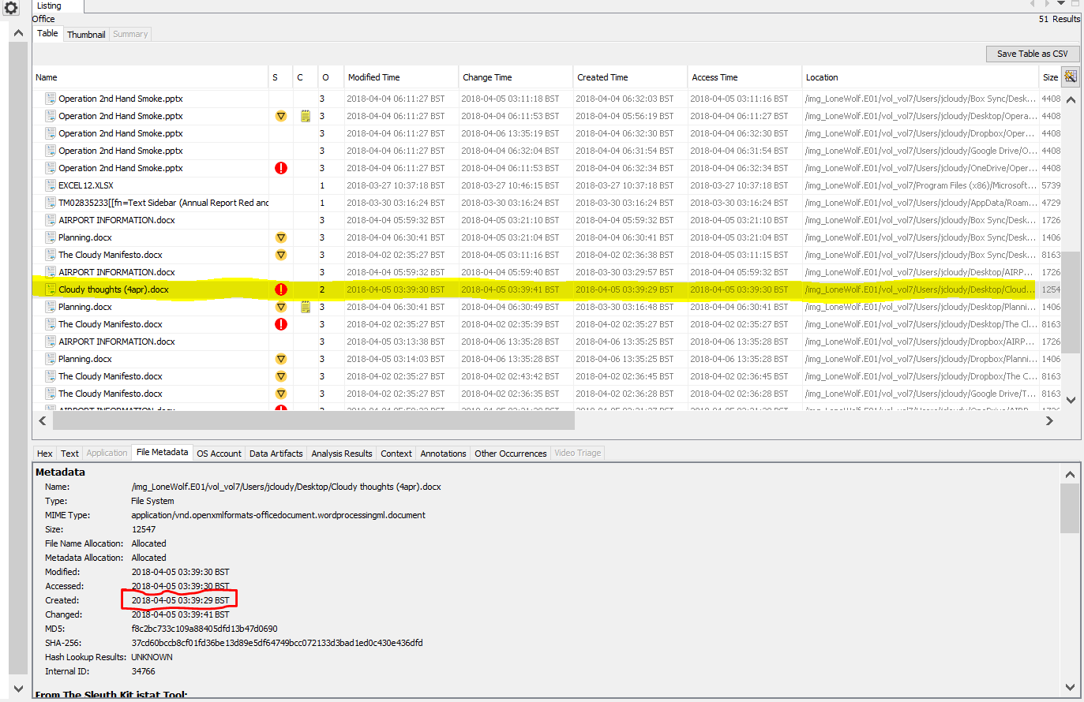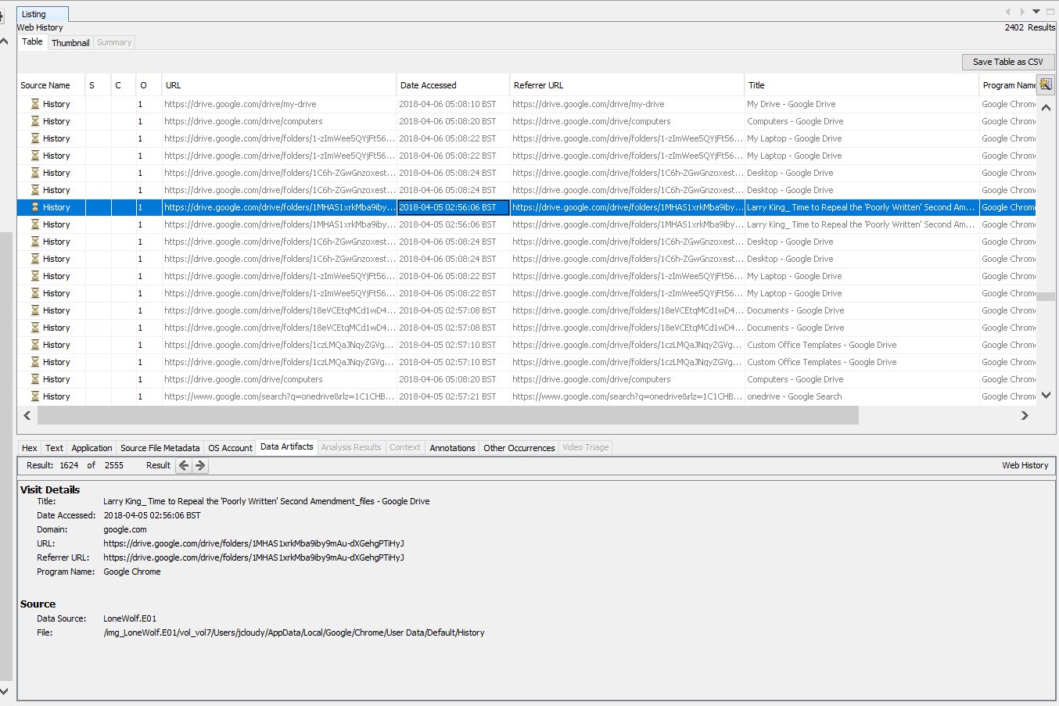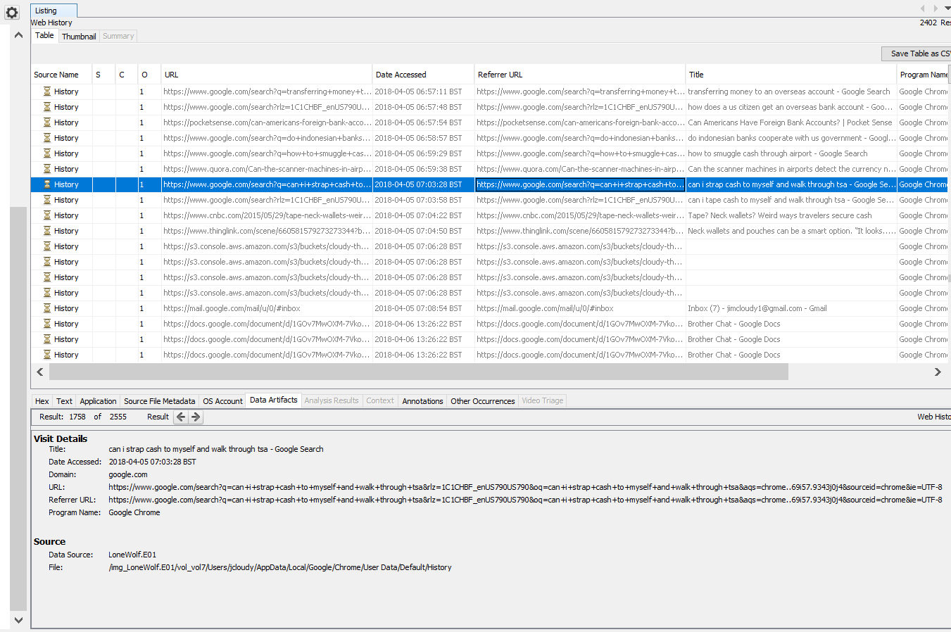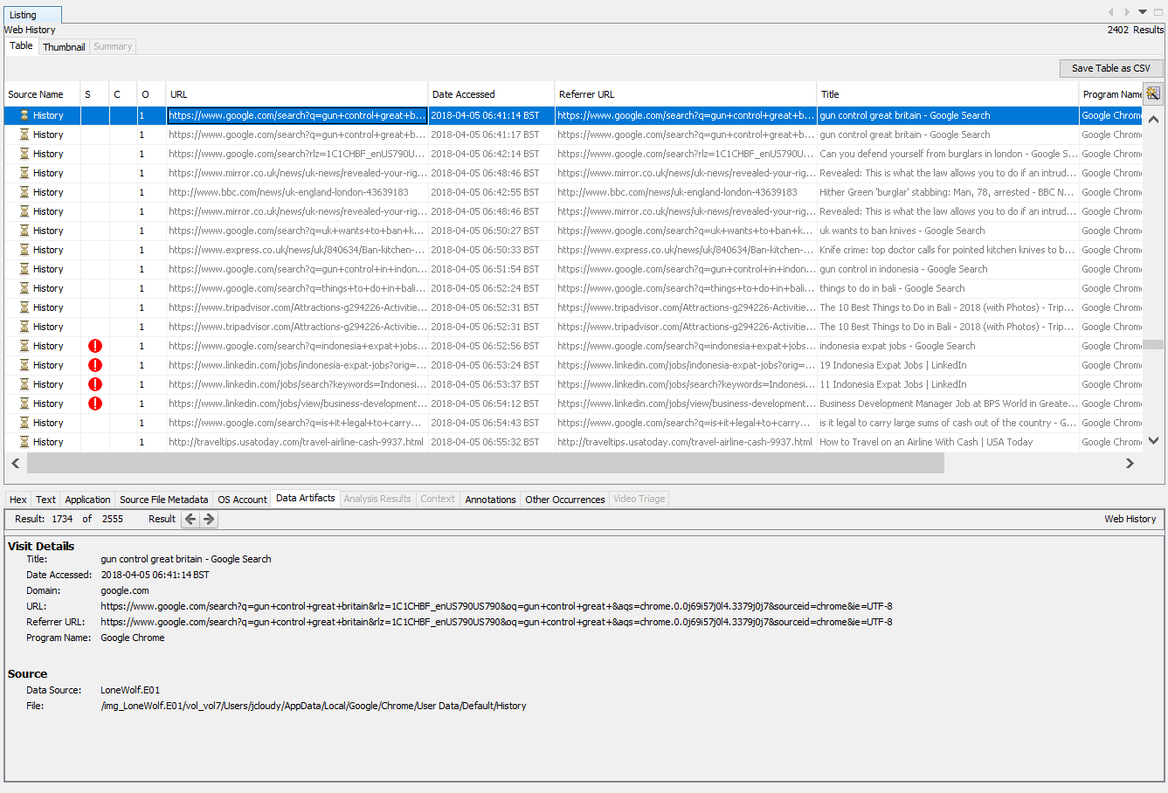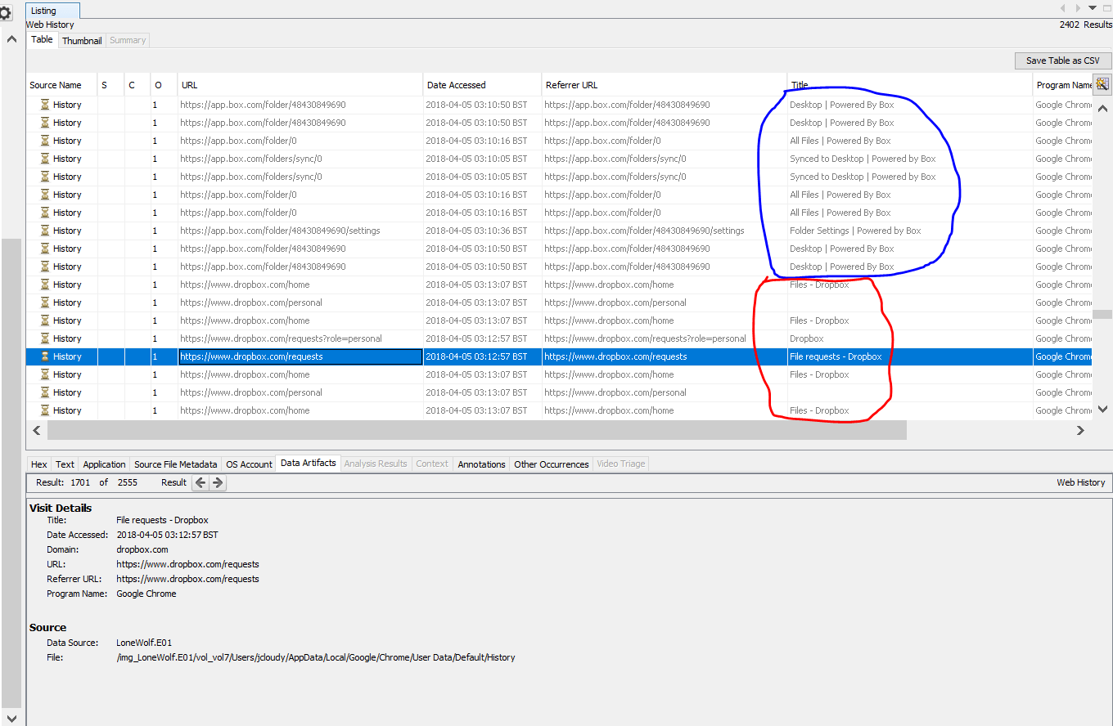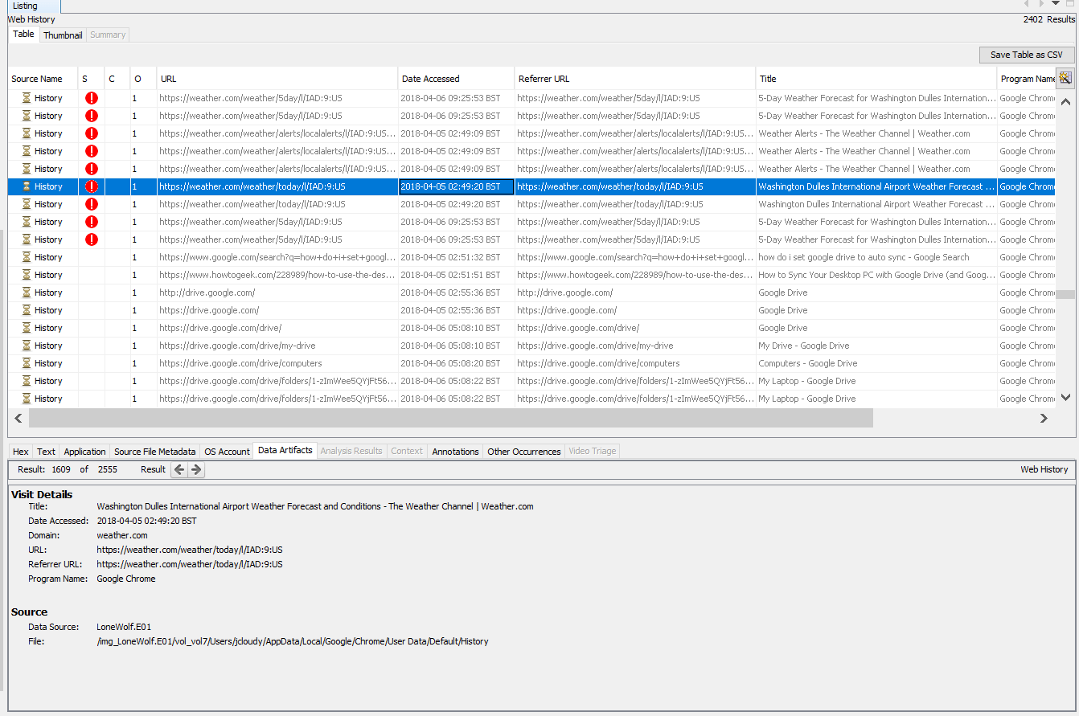

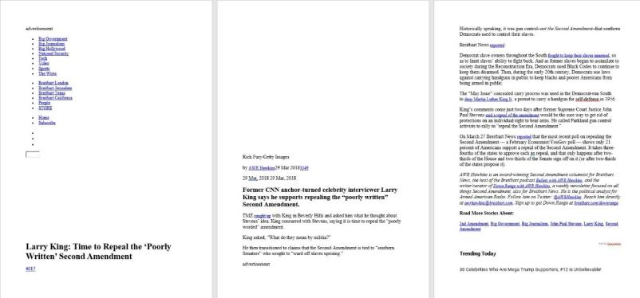

**7.5. OTHER EXHIBITS ATTACHEMENT**

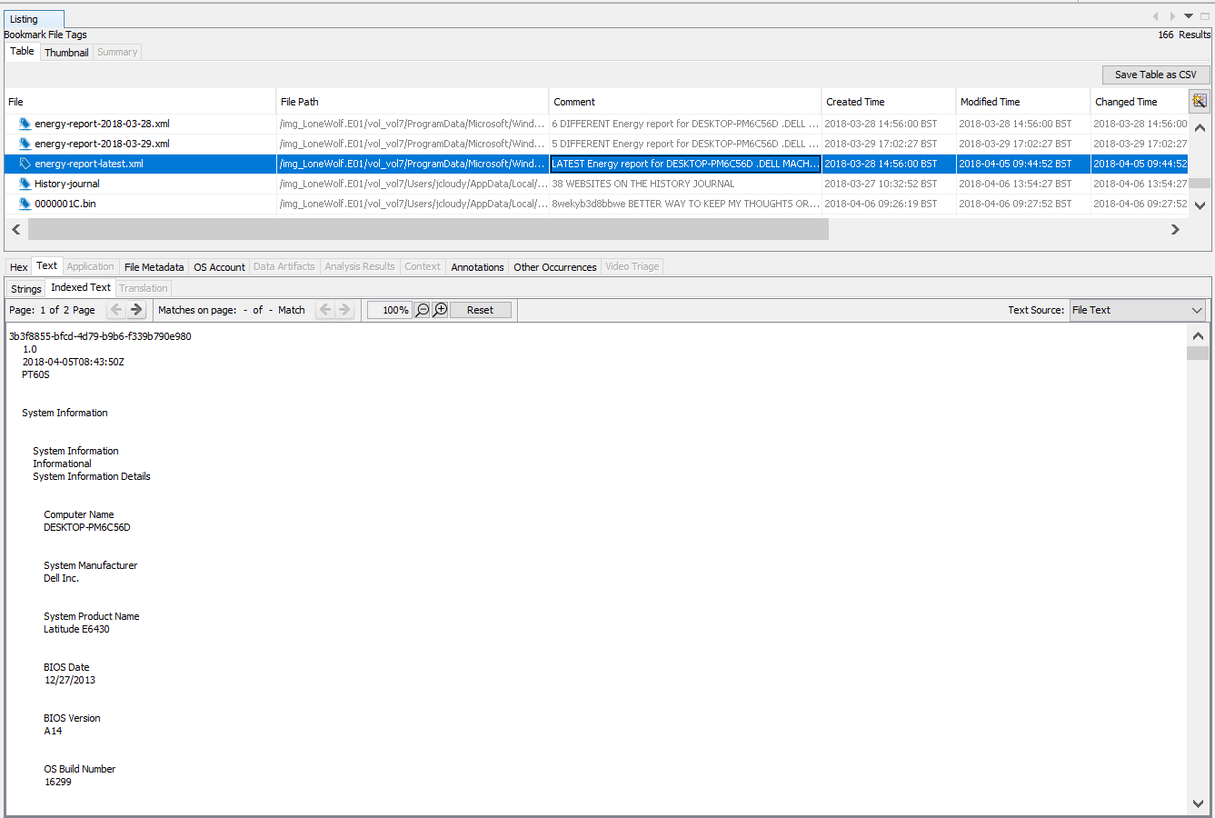

**7.6 Contemporaneous Notes – EXHIBIT MDX/E8**

**7.7 Autopsy Software Report- EXHIBIT MDX/E9**

**7.8 Other Investigation Evidence- Excel, JPEG, HTML etc. - EXHIBIT MDX/E10**

**References:**

*An explanation of ACPO Guidelines for digital based evidence* (2022) *Athena Forensics*. Available at: https://athenaforensics.co.uk/acpo-guidelines-for-computer-forensics/ (Accessed: December 3, 2022).

Garfinkel, S. *et al.* (2018) *2018 lone wolf scenario*, *Digital Corpora*. Available at: https://digitalcorpora.org/corpora/scenarios/2018-lone-wolf-scenario/ (Accessed: December 3, 2022).

*2021 Guidelines Manual Annotated* (2021) *United States Sentencing Commission*. Available at: https://www.ussc.gov/guidelines/2021-guidelines-manual-annotated (Accessed: December 3, 2022).

Horsman, G., (2020). ACPO principles for digital evidence: Time for an update? *Forensic Science International: Reports*, 2, p.100076.

*ISO/IEC 27042:2015* (2021) *ISO*. Available at: https://www.iso.org/standard/44406.html (Accessed: December 3, 2022).

Lallie, H. and Pimlott, L., (2012). Applying the ACPO Principles in Public Cloud Forensic Investigations. *Journal of Digital Forensics, Security and Law*.

Participation, E. (1990) *Computer misuse act 1990*, *Legislation.gov.uk*. Statute Law Database. Available at: https://www.legislation.gov.uk/ukpga/1990/18/contents (Accessed: December 3, 2022).

Participation, E. (2006) *Police and justice act 2006*, *Legislation.gov.uk*. Statute Law Database. Available at: https://www.legislation.gov.uk/ukpga/2006/48/contents (Accessed: December 3, 2022).